
FACULTY OF TECHNOLOGY AND ENGINEERING
DEVANG PATEL INSTITUTE OF ADVANCE TECHNOLOGY
AND RESEARCH

DEPARTMENT OF COMPUTER ENGINEERING

A.Y 2026 – 27 Semester – 3

LAB MANUAL

CSUC201 Fundamentals of Data Structures and Algorithms

Practical 7: Queue Implementation using Array and Linked List, with Structure Simulation
Aim:
To implement queue using array and linked list, and apply queue-based logic to number generation, and structure simulation problems.
Problem 1 :
A government office has a token counter that issues tokens to visitors. The counter can hold at most n tokens at a time. New visitors join from one end and are served from the other end in the order they arrived. If the counter is full, no new token can be issued, and if it is empty, no one can be served. Given a sequence of join and serve operations, implement this fixed-capacity token system and print the current front token after each operation. Report an error if an operation cannot be performed.
Describe how your solution tracks the front and rear of the queue. What happens to your front and rear pointers over time as join and serve operations keep happening, and does your solution handle the case where space appears to run out even though slots have been freed?
Link:
https://github.com/yakshu205/DSA/tree/main/Sorting%20algo/practical-7
Output:
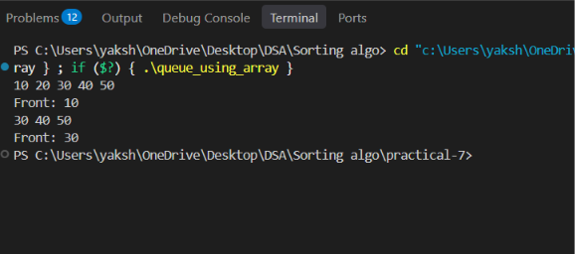

Conclusion:
The program implements a fixed-capacity queue using an array, with front and rear pointers to manage token serving and joining. It reports errors when the queue is full or empty, but freed spaces at the front are not reused in a simple linear queue.

Problem 2
A hospital emergency ward receives patients continuously and attends to them strictly in the order they arrived, with no upper limit on how many can be waiting at once. New patients are added at the back and the doctor always attends to the patient at the front. Given a sequence of arrive and attend operations, implement this unlimited patient queue and print the current front patient after each operation.
Describe how your solution differs from Problem 1 in how it manages capacity. What happens in your solution when the attend operation is called on an empty ward with no patients waiting?
Link:
https://github.com/yakshu205/DSA/tree/main/Sorting%20algo/practical-7
Output:
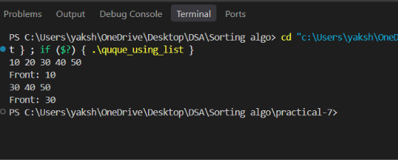

Conclusion:
The program implements an unlimited queue using a linked list, allowing patients to be added dynamically without a fixed capacity. If attend is called when the queue is empty, it displays an error message and performs no operation.

Key Questions / Analysis / Interpretation to be Evaluated During/After
Implementation :

[Problem 1] A simple array queue eventually reports being full even when slots have been freed at the front. Explain why this happens structurally — not by tracing an example, but by describing what the front and rear pointers represent and what their movement pattern causes over time.
Sol:
The front pointer moves ahead after deletion, but the rear pointer keeps moving toward the end of the array.
So, empty spaces at the front remain unused, causing the queue to become full.

[Problem 2] Your linked list queue has no capacity limit. If arrive operations vastly outnumber attend operations over a long period, what real consequence would this have on the system, and where in your code is that consequence invisible?
Sol:
If arrive happens much more than attend, the queue keeps growing and uses more RAM. Eventually, it may run out of memory. This is invisible in arrive() because: new Node();
creates a node without checking available memory or capacity.

